**Scala Installation**

NAME : M SAI SATHVIKA REDDY

USN : 22BTRAD024

CSE AIDE

Step 1: Download and install Java.

<https://www.java.com/en/download/manual.jsp>

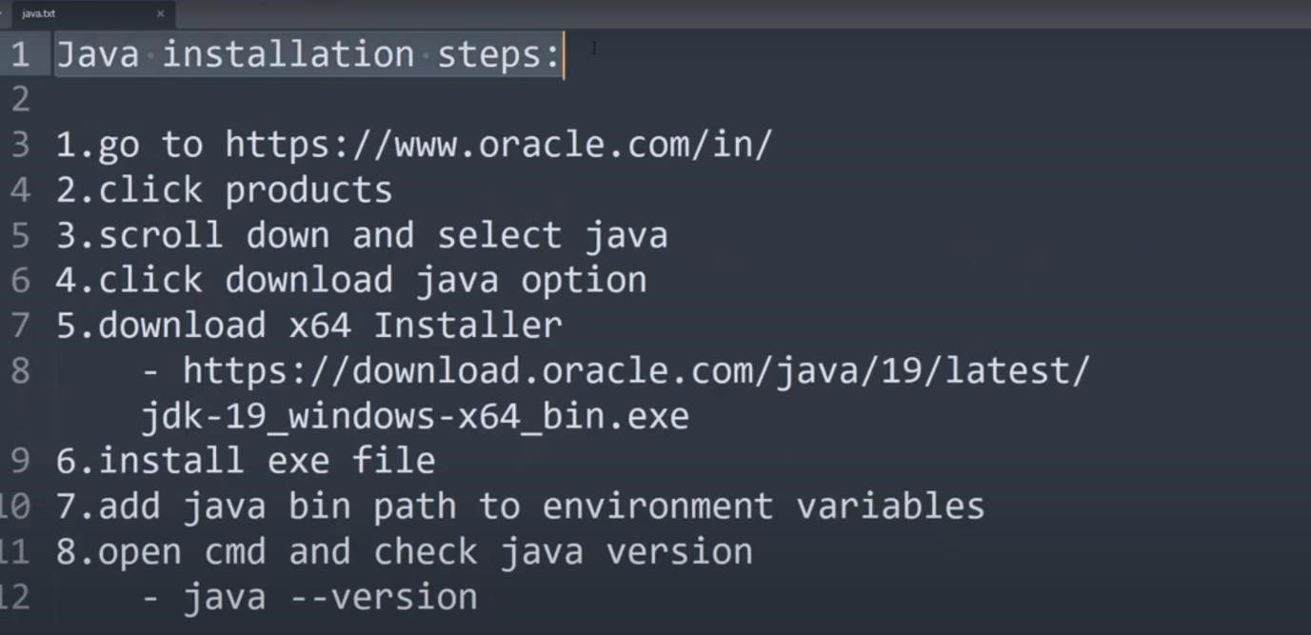

Step2: Download and install Scala <https://www.scala-lang.org/download/><https://www.scala-lang.org/download/2.13.11.html>

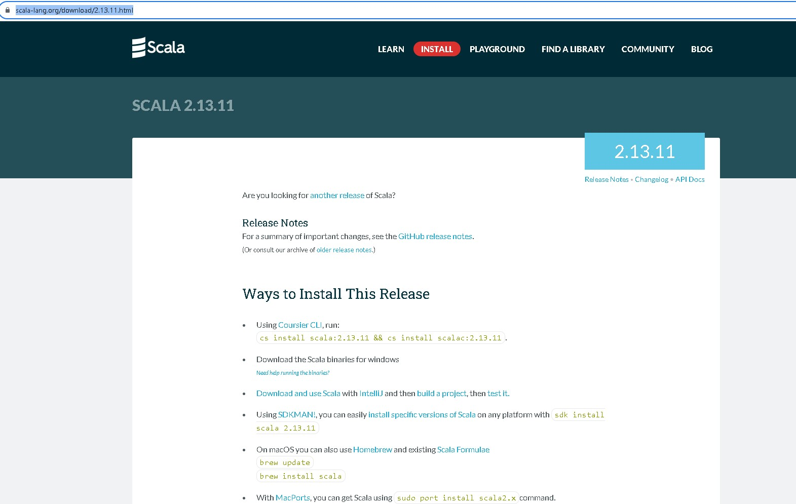

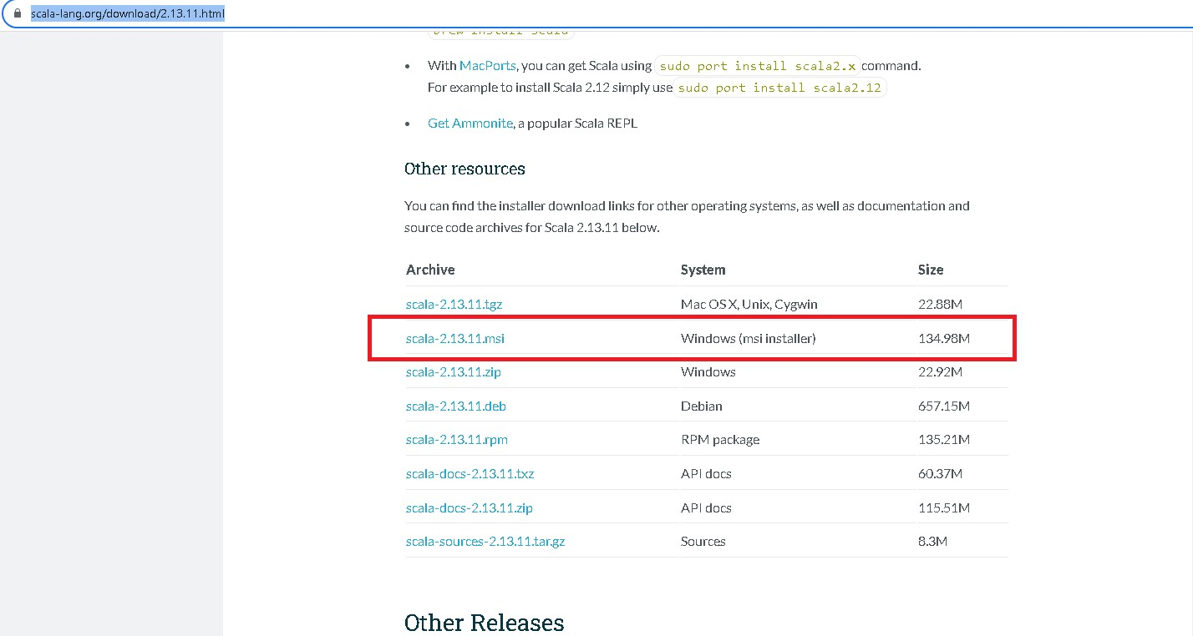

Install msi version.

Step3:

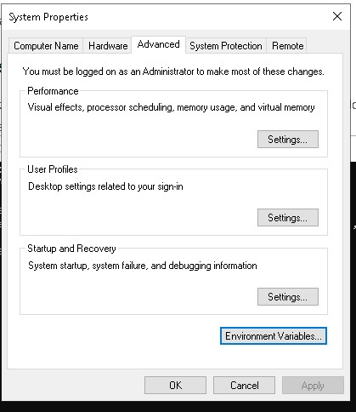

Step4:

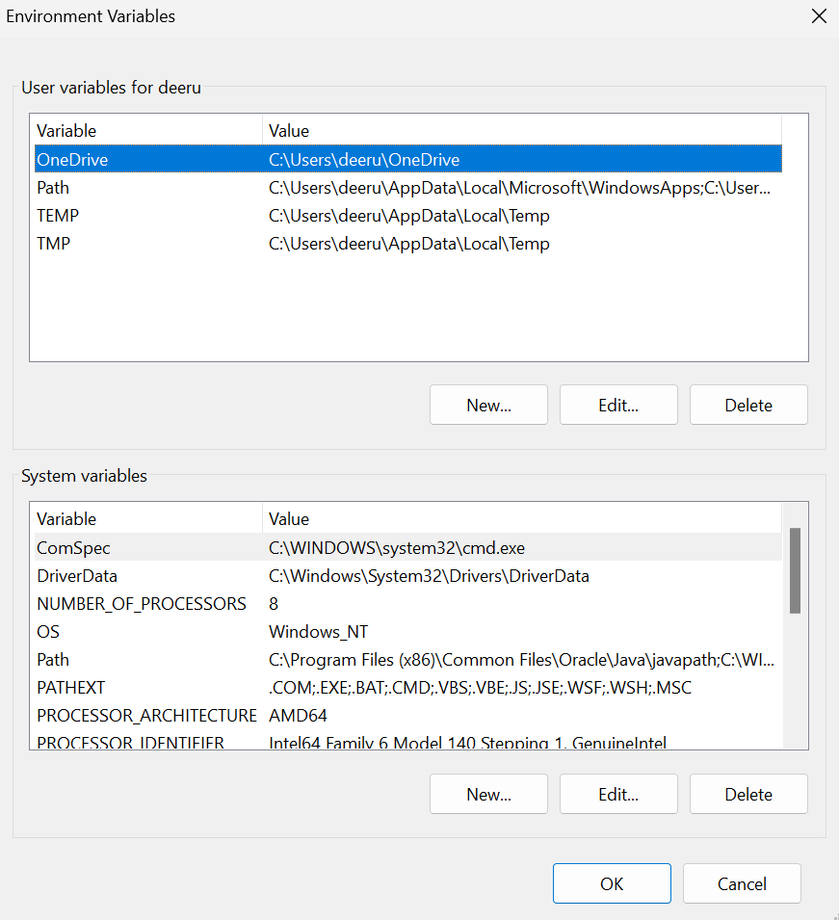

Step 5:

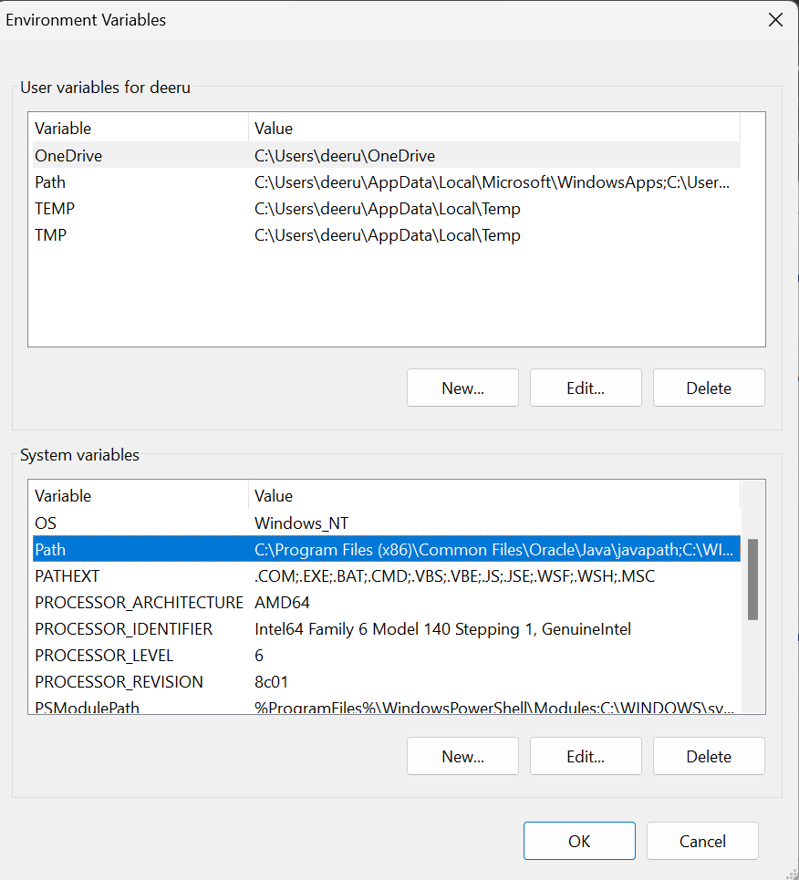

Step6: EDIT

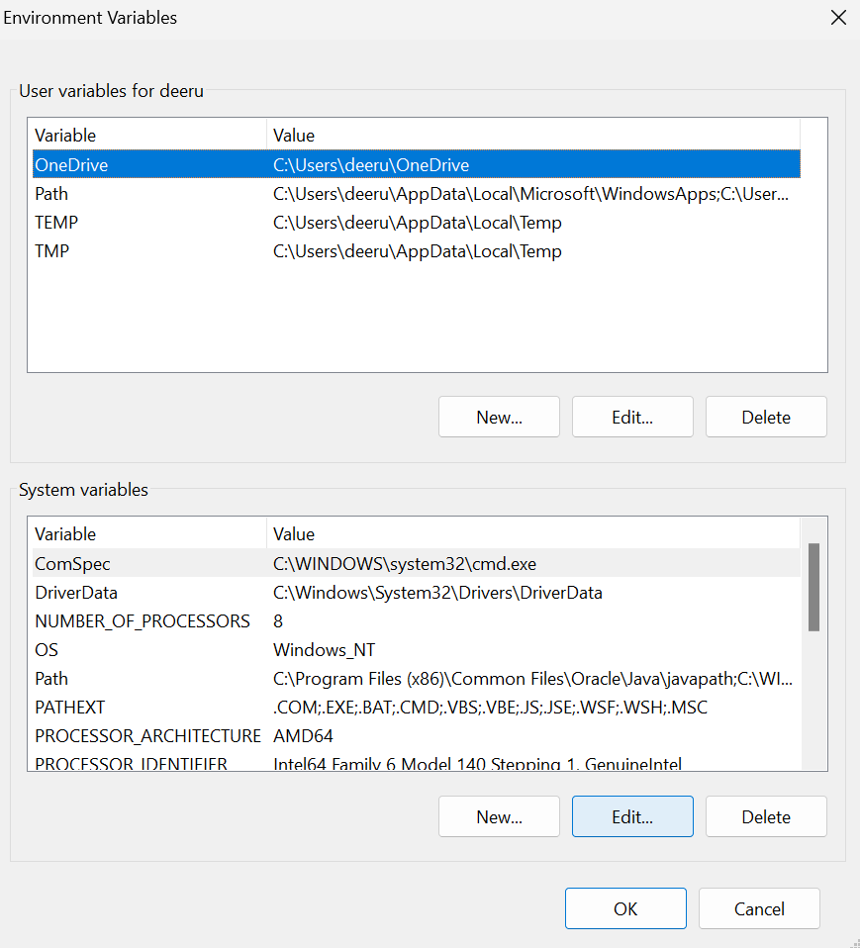

Step7:

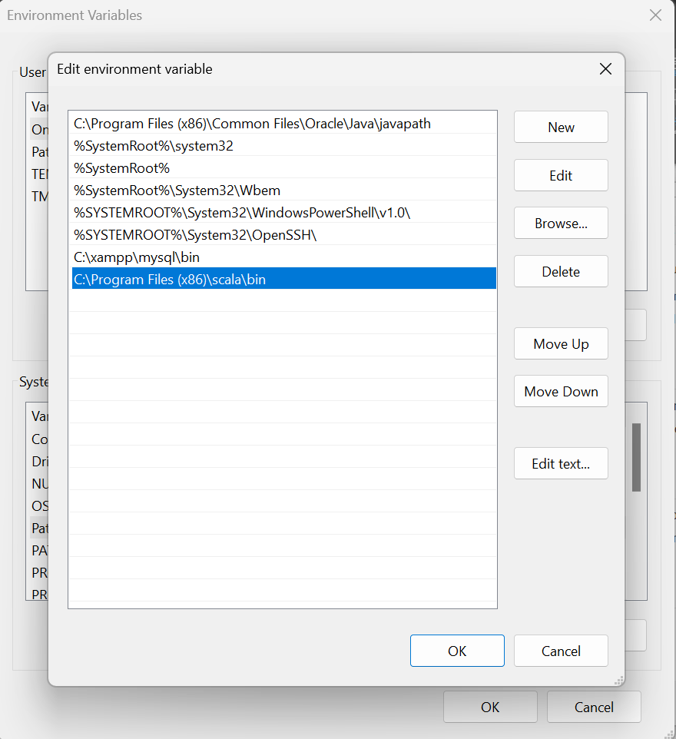

Scala is installed at this path.

Confirm the version with cmd .

